POC – Automation of Postfix Integration using Secrets Manager

Introduction
- Brief overview: This POC demonstrates an automated process for updating SMTP credentials on multiple EC2 instances running Postfix. The solution leverages AWS Systems Manager (SSM) and Secrets Manager store to securely manage and deploy credential updates across the infrastructure.

- Importance: Ensures secure and efficient management of email sending credentials across the infrastructure. This automation significantly reduces the risk of human error in manual updates, enhances security by allowing more frequent credential rotations, and saves considerable time and effort in managing large-scale email systems.

- Scope: The POC covers the entire workflow from storing credentials securely to deploying them across multiple servers, demonstrating the feasibility and efficiency of the automated approach in a production-like environment.

System Components
- Postfix: Mail Transfer Agent installed on EC2 instances. Postfix is configured to use external SMTP servers for email relay, requiring regular updates to SMTP authentication credentials.

- AWS EC2 Instances: Hosts running Postfix that require credential updates. These instances are tagged and managed as part of the AWS infrastructure, allowing for easy targeting with SSM.

- AWS Systems Manager (SSM): Used to execute scripts on multiple EC2 instances. SSM provides a secure and auditable way to run commands across the EC2 fleet without needing to log into each server individually.

- AWS Secrets Manager : Securely stores SMTP credentials. It offers encryption at rest and in transit, automatic rotation capabilities, and fine-grained access control through IAM policies.

- sasl_passwd file: Postfix configuration file that stores SMTP authentication information. This file needs to be updated on each server whenever SMTP credentials change, and Postfix needs to be reloaded to apply the changes.

Automation Workflow

- Trigger: Applying an SSM Association initiates the update process. This can be done manually through the AWS Console or API, or scheduled for automatic execution at regular intervals.

- Credential Retrieval: Script fetches latest SMTP credentials from Secrets Manager. The script uses the AWS SDK to securely retrieve the credentials, ensuring that no sensitive information is logged or exposed.

- File Update: sasl_passwd file on each selected EC2 instance is updated with new credentials. The script backs up the existing file, writes the new credentials, and sets appropriate permissions to ensure security.

- Postfix Reload: Configuration changes are applied without service interruption. The script executes a Postfix reload command, allowing the new credentials to take effect without stopping the email service.

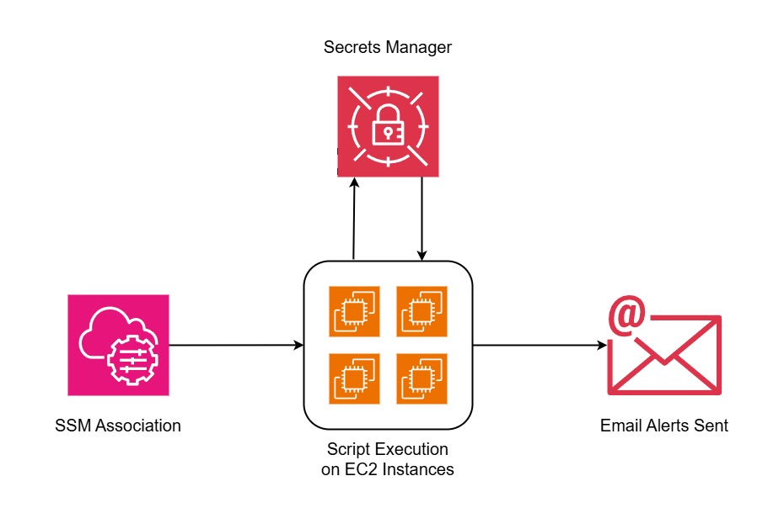

Implementation Details
Step 1:
Create new SMTP Credentials from the SES Console.
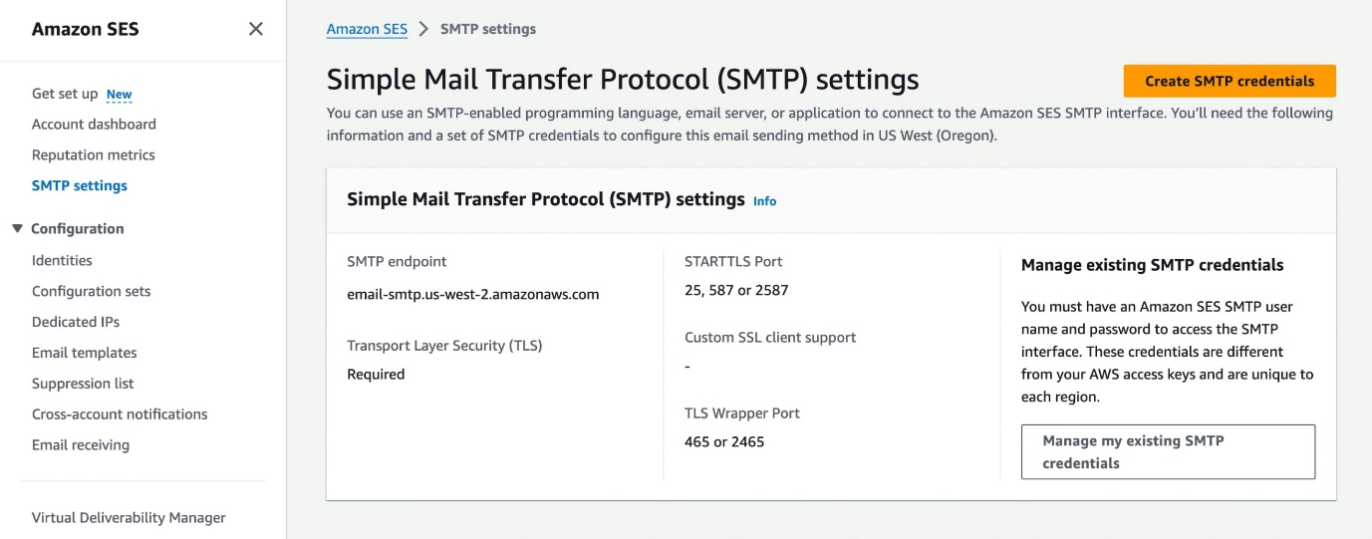
Give user a name custom name accordingly.
Once the user has been created, for the time being make sure to Download the .csv file and keep these credentials locally.
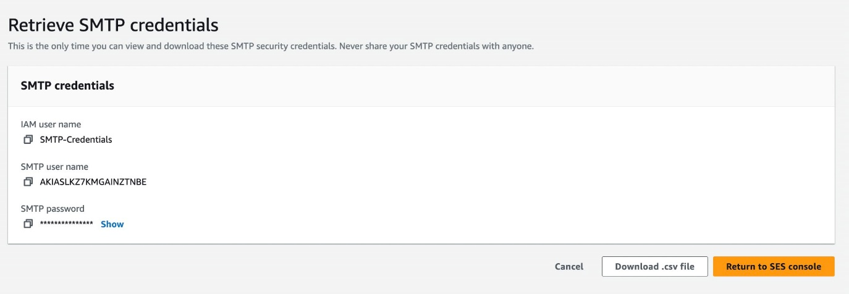

Step 2:
Create a new Sceret in the AWS Secrets Manager and save the newly created SMTP Credentials as plain text values. This is because the secret manager will work as a centralized place to fetch credentials for all the postfix servers.
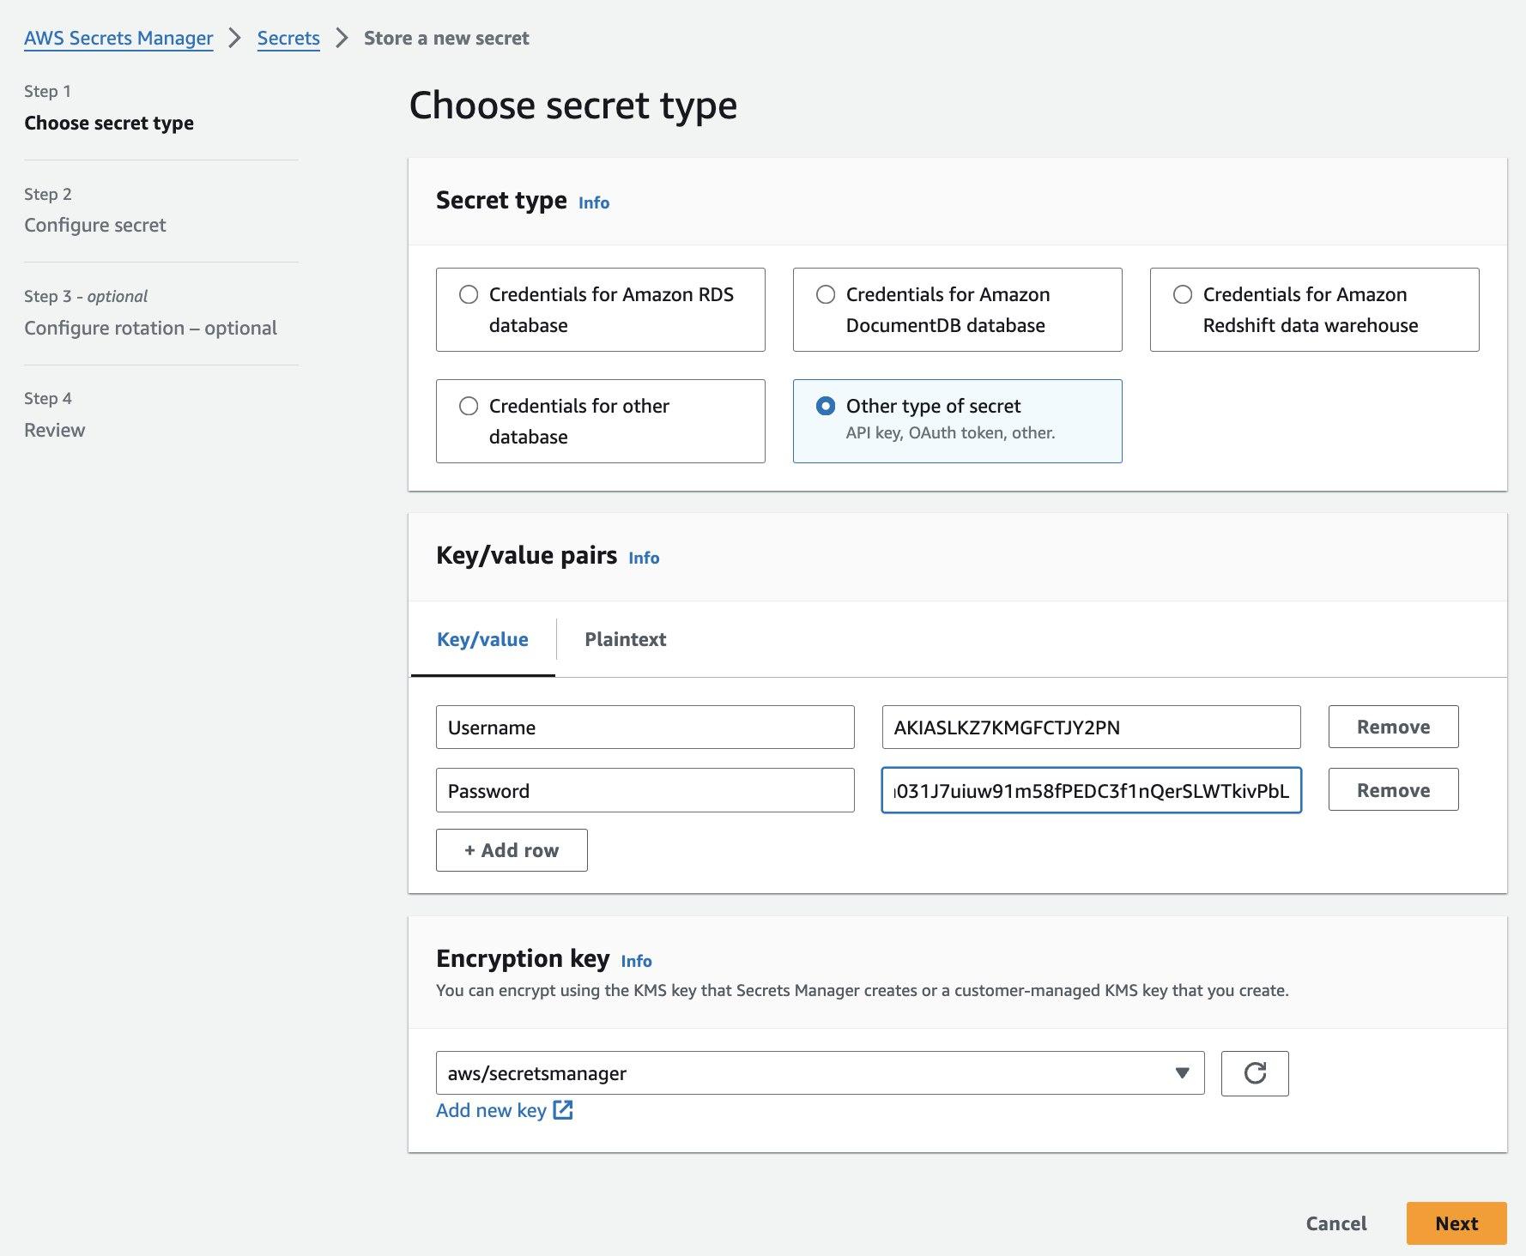

Step 3:
Setting up the script on ssm association

Script

The script performs the following steps:

1. Retrieves the SMTP username and password from AWS Secrets Manager using the provided secret ID.
2. Takes the backup of sasl_passwd file and Updates the Postfix SASL (Simple Authentication and Security Layer) configuration file with the new SMTP credentials.
3. Reloads the Postfix service to apply the changes.
4. Sends a notification email to the specified recipient, including the hostname and IP address of the server where the script is run.

Note: All the ec2 instance’s roles must have below mention IAM policy
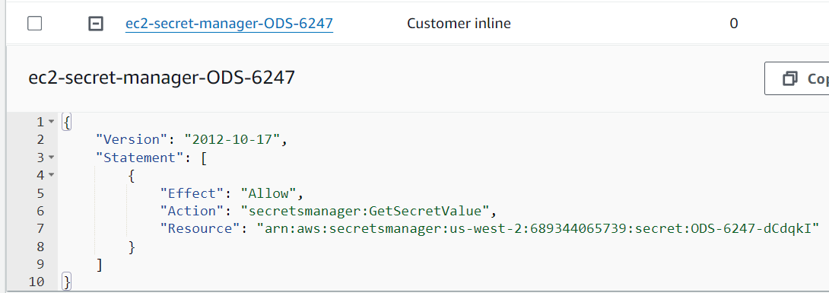

Step 4:
Create an SSM Association, choose the EC2 instance on which the postfix is running.
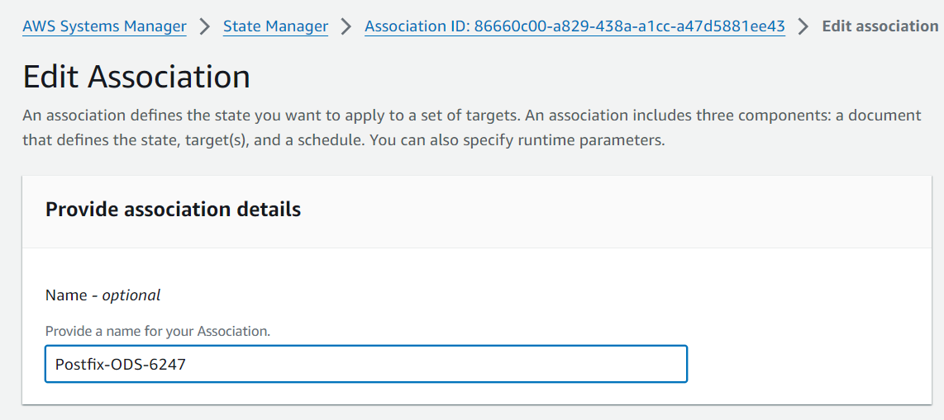
Select Document type as AWS-RunShellScript
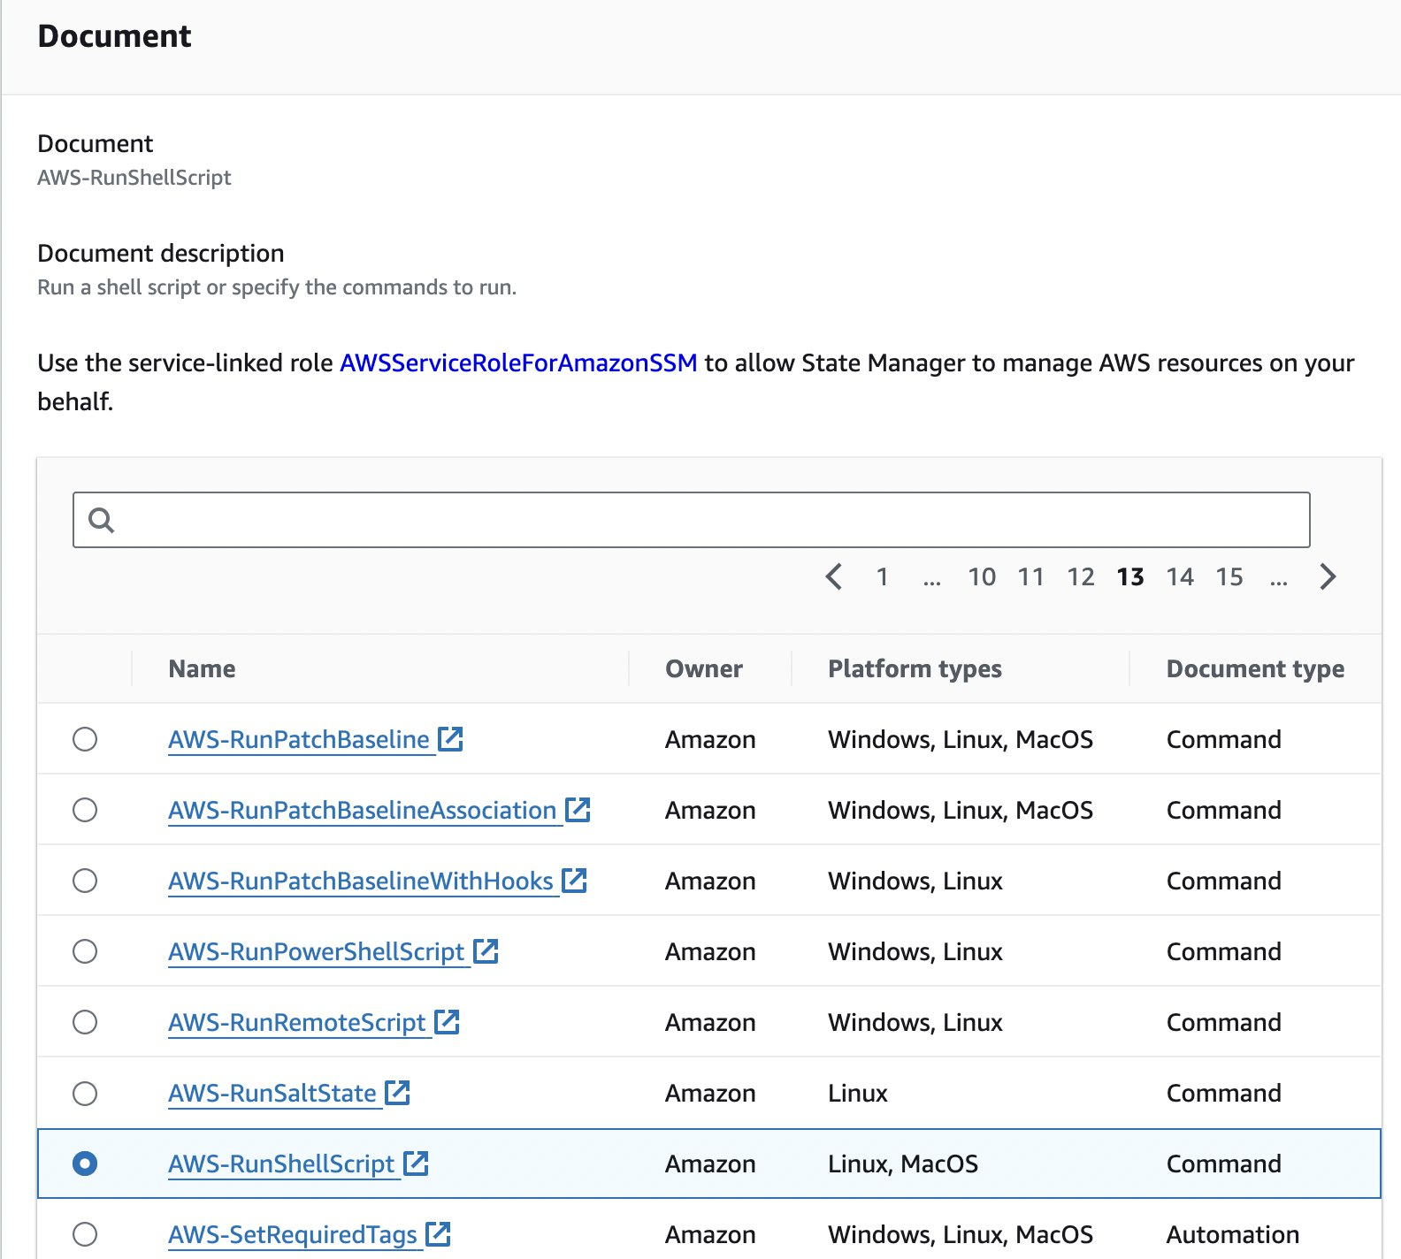

Pass the script to run on servers- will select servers in next step.
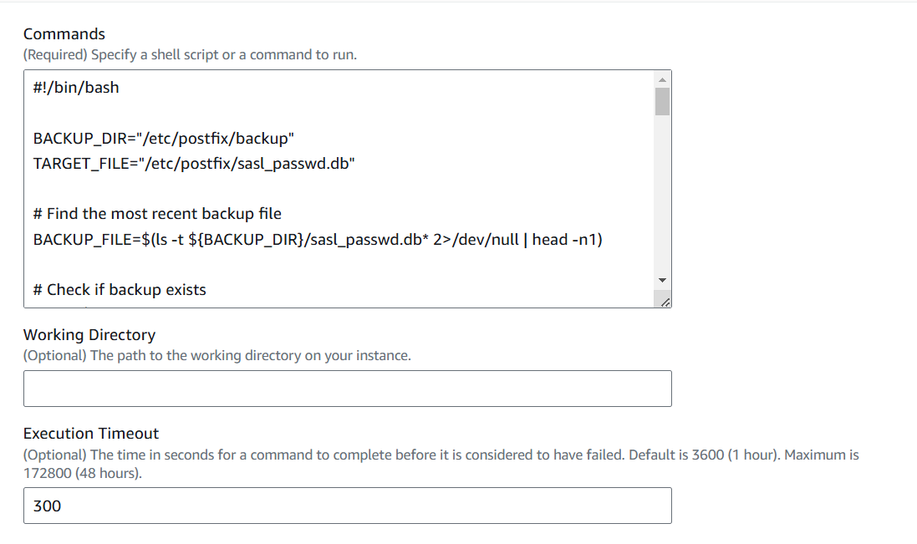
Select Choose instances manually and select the instances accordingly.
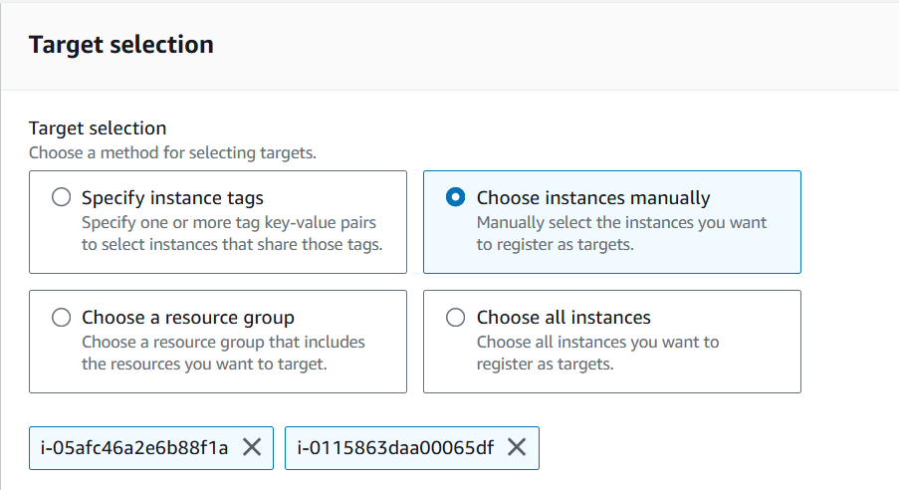
Set it to no schedule and create association
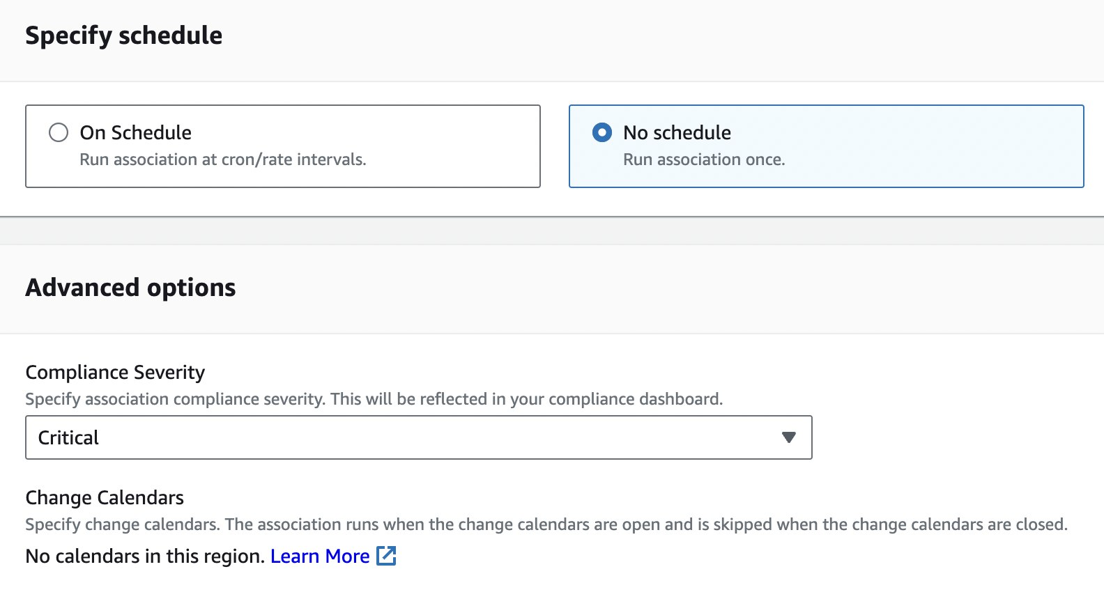
Hit apply association, script will run, fetch new credentials from secret manager, set them in the server, send confirmational email as below images. 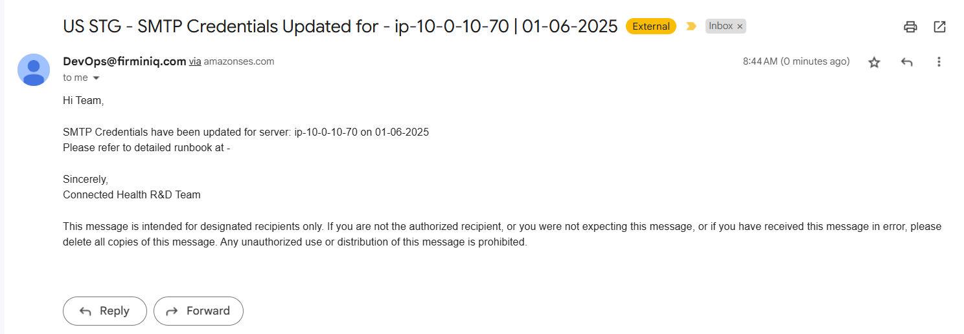
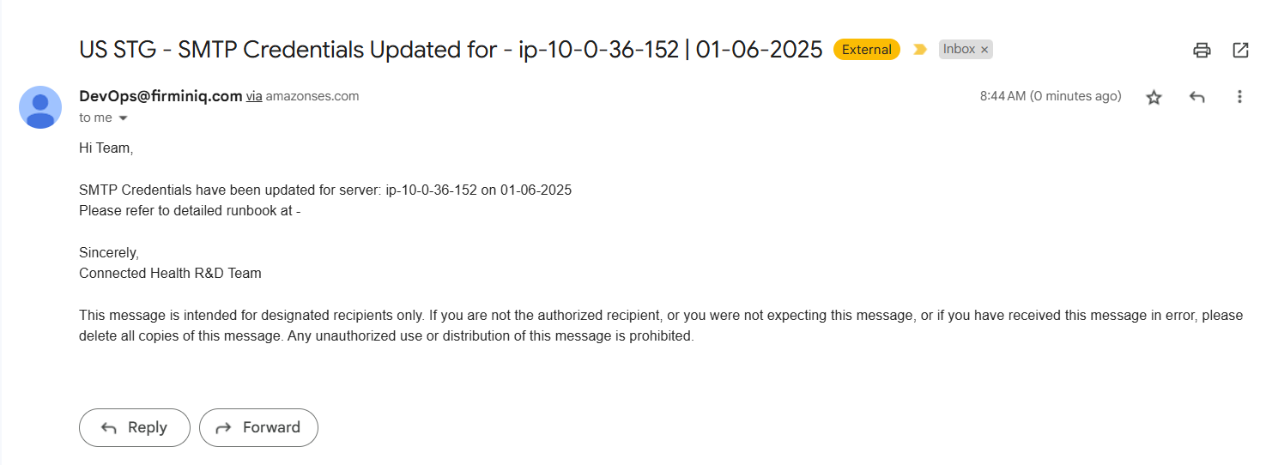
Output can be verified by going to the latest execution id as below output shows the successful completion of the job.
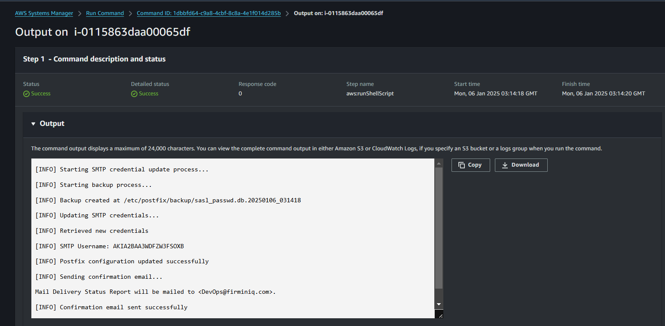

Conclusion
- Summary of Benefits: Recap of the advantages of this automated credential update system. This highlights the improved security, reduced operational overhead, and increased reliability achieved through the automation.

- Recommendations: Suggested next steps for production deployment and further improvements. This includes any identified areas for optimization, additional features to consider, and a proposed timeline for full production rollout.

